
FT/PHQP/1221/A 20-SEP-2021
FIRST TERM EXAMINATION (2021-22)
Subject: PHYSICS  Grade: XII |  |  |  |  | Max. Marks:3 5  Time: 90 Minutes
Name: |  |  |  |  |  |  |  |  | Section: | Roll No:
- General Instructions:
1. The Question Paper contains three sections.
2. Section A has 25 questions. Attempt any 20 questions.
3. Section B has 24 questions. Attempt any20 questions.
4. Section C has 6 questions. Attempt any 5 questions.
5. All questions carry equal marks.
6. There is no negative marking.
SECTION A
This section consists of 25 multiple choice questions with overall choice to attempt any 20 questions. In case more than desirable number of questions are attempted, ONLY first 20 will be considered for evaluation.
 | The work done in moving a positive charge on an equipotential surface is
 | a. | finite and positive |  |  |  | b. |  | infinite
 | c. | finite and negative |  |  |  | d. |  | zero
 | Two-point charges q1 = 4 μC & q2 = 9 μC are placed 20 cm apart. The electric field due to them will be zero on the line joining them at a distance of
 | a. | 8 cm from q1 |  |  |  | b. |  | 8 cm from q2
 | c. | 80/13 cm from q1 |  |  |  | d. |  | 80/13 cm from q2
 | An electric dipole has the magnitude of its charge as q and its dipole moment is p. It is placed in a uniform electric field E. If its dipole moment is along the direction of the field, the force on it and its potential energy are respectively
 | a. | q. and p. |  |  |  | b. |  | Zero and minimum
 | c. | q. and maximum |  |  |  | d. |  | 2q. and minimum
Three identical capacitors of capacitances C are connected between the two pints A and B as shown in the figure .
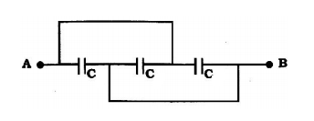
The equivalent capacitance between A and B is
 | a. | 3C |  |  |  | b. |  | C/3
 | c. | 2C |  |  |  | d. |  | C
 | Two charged spheres separated by a distance d exert some force on each other. If they are immersed in a liquid of dielectric constant 2, then what is the force exerted, if all other conditions are same?
 | a. | F/2 |  |  |  | b. |  | F
 | c. | 2F |  |  |  | d. |  | 4F
 | If the flux of the electric field through a closed surface is zero then
 | a. | Electric field must be zero everywhere on the surface |  |  |  | b. |  | Total charge inside the surface must be zero
 | c. | Electric field must be uniform throughout the closed surface |  |  |  | d. |  | Charge outside the surface must be zero
 | A parallel plate capacitor having capacitance C farad is connected with a battery of emf V volts. Keeping the capacitor connected with the battery, a dielectric slab of dielectric constant K is inserted between the plates. The dimensions of the slab are such that it fills the space between the capacitor plates. Then
 | a. | charge on the capacitor plates remains the same |  |  |  | b. |  | charge on the plates increases K times
 | c. | potential difference between the plates decreases to V/K |  |  |  | d. |  | all of these
 | Wheatstone Bridge experiment is most sensitive, when:
 | a. | All four resistances are approximately equal |  |  |  | b. |  | One of the resistances is very high as compared to others
 | c. | One of the resistances is very low as compared to others |  |  |  | d. |  | Any two resistances are equal to infinity
 | Three electric bulbs of 40W, 60W and 100W have the tungsten wire of the same diameter. Then the longer wire is used by
 | a. | 60W |  |  |  | b. |  | 100W
 | c. | 40W |  |  |  | d. |  | All use the same length
 | A piece of copper and silicon are cooled from room temperature to 100 K. The resistance of
 | a. | each of them increases |  |  |  | b. |  | each of them decreases
 | c. | copper increases and that of silicon decreases |  |  |  | d. |  | copper decreases and that of silicon increases
 | Drift velocity v_{d} varies with the intensity of electric field E as per the relation
 | a. |  |  |  |  | b.
 | c. |  |  |  |  | d. |  | ²
 | The resistivity of a conductor in which a current density of 2.5 Am^{–2} is found to exist, when an electric field of 15 Vm^{–1} is applied on it
 | a. | 2 Ωm |  |  |  | b. |  | 6 Ωm
 | c. | 4 Ωm |  |  |  | d. |  | 8 Ωm
- ` | Two resistance filaments of same length are connected first in series and then in parallel. Find the ratio of power dissipated in both cases assuming that equal current flows in the main circuit.
 | a. | 1 : 4 |  |  |  | b. |  | 4: 1
 | c. | 1 : 2 |  |  |  | d. |  | 2 : 1
 | Kirchhoff’s II law for the electric network is based on:
 | a. | Law of conservation of charge |  |  |  | b. |  | Law of conservation of energy
 | c. | Law of conservation of angular momentum |  |  |  | d. |  | Law of conservation of mass
 | A magnet suspended freely at the magnetic pole will show its direction
 | a. | vertical |  |  |  | b. |  | horizontal
 | c. | 45° from the horizontal |  |  |  | d. |  | turn in any direction
 | Phospher- bronze wire is used in suspension because it has
 | a. | High conductivity |  |  |  | b. |  | High resistivity
 | c. | Large couple per unit twist |  |  |  | d. |  | Small couple per unit twist
Two similar coils are kept mutually perpendicular such that their centres coincide. At the centre , find the ratio of the magnetic field due to one coil and the resultant magnetic field by both coils, if the same current is flown
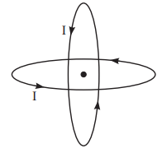
 | a. |  |  | 1: |  |  | b. |  | 1:2
 | c. |  |  | 2:1 |  |  | d. |  | : 1
 | Which of the following statements is not correct about the magnetic field?
 | a. | magnetic lines of force don’t cut each other |  |  |  | b. |  | inside the magnet the lines go from north to south pole of the magnet
 | c. | the magnetic lines from a closed loop |  |  |  | d. |  | tangents to the magnetic lines give the direction of the magnetic field.
 | At a certain place, horizontal component of Earth’s field is √3 times the vertical component. The angle of dip at this place is
 | a. | 0 |  |  |  | b. |  | π/3
 | c. | π/6 |  |  |  | d. |  | none of the above
Two circular coils can be arranged in any of three situations as shown in the figure. Their mutual inductance will be
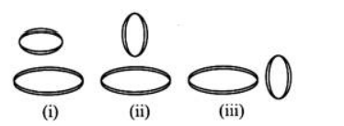
 | a. | maximum in situation (i) |  |  |  | b. |  | maximum in situation (ii)
 | c. | maximum in situation (iii) |  |  |  | d. |  | same in all situations
 | Figure shows planar loops of different shapes moving out of or into a region of a magnetic field which is directed normal to the plane of the loop away from the reader. The direction of induced current in (i),(ii) and (iii) |  |  |  |  |  | 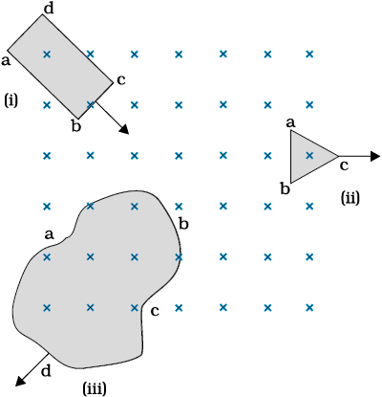
 | a. | Clockwise, clockwise , clockwise |  |  |  | b. |  | Anti-clockwise, clockwise , clockwise
 | c. | Anti-clockwise, clockwise , anti-clockwise |  |  |  | d. |  | Anti-clockwise, anti-clockwise , clockwise
 | The magnetic flux linked with a coil, in Weber, is given by the equations Φ = 3t²+4t+9. Then the magnitude of induced e.m.f. at t = 2 second will be
 | a. | 2 volt |  |  |  | b. |  | 4 volt
 | c. | 8 volt |  |  |  | d. |  | 16 volt
 | Alternating voltage V = 400 sin (500 π t) is a applied across a resistance of 0.2 k Ω. The r.m.s. value of current will be equal to
 | a. | 14.14 A |  |  |  | b. |  | 1.414
 | c. | 0.1414 A |  |  |  | d. |  | 2.0 A
In a transformer, the no. of turns of primary and secondary coil are 500 and 400 respectively.
If 220 V is supplied to the primary coil, then ratio of currents in primary and secondary coils
is
 | a. | 4:5 |  |  |  | b. |  | 5:4
 | c. | 5:9 |  |  |  | d. |  | 9:5
 | A resistor and a capacitor are connected in series with an a.c. source. If the potential drop across the capacitor is 5 V and that across the resistor is 12 V, the applied voltage is
 | a. | 12 V |  |  |  | b. |  | 13 V
 | c. | 17 V |  |  |  | d. |  | 5 V
SECTION B
This section consists of 24 multiple choice questions with overall choice to attempt any 20 questions. In case more than desirable number of questions are attempted, ONLY first 20 will be considered for evaluation.
An electric dipole with dipole moment 4 × 10⁻⁹C m is aligned at 30° with the direction of a
uniform electric field of magnitude 5 × 10⁴ NC⁻¹ Calculate the magnitude of the torque acting
on the dipole.
 | a. | 10⁻⁴ Nm |  |  |  | b. |  | 1.71x10⁻⁴ Nm
 | c. | 10⁻¹³ Nm |  |  |  | d. |  | 1.71x10⁻¹³ Nm
Three infinitely long charge sheets are placed which charge density as shown in figure. The electric field at point P is
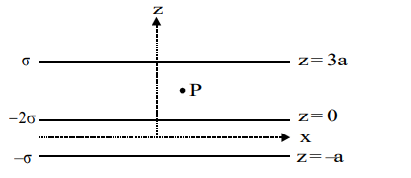
 | a. | 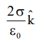 |  |  |  | b. |  | 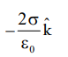
 | c. | 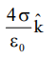 |  |  |  | d. |  | 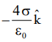
 | ABC is an equilateral triangle. Charges +q are placed at each corner. The electric field intensity at the centroid of triangle will be |  |  |  |  |  | 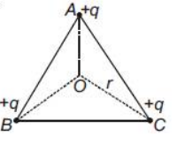
 | a. | 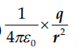 |  |  |  | b. |  | 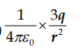
 | c. | 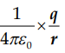 |  |  |  | d. |  | Zero
 | In the figure shown, conducting shells A and B have charges Q and 2Q distributed uniformly over A and B .Value of VA – VB is |  |  |  |  |  | 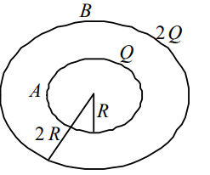
 | a. | 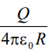 |  |  |  | b. |  | 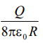
 | c. | 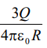 |  |  |  | d. |  | 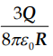
Four condensers each capacity 4 μ F are connected as shown in figure VP – VQ = 15 volts. The energy stored in the system is
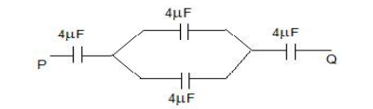
 | a. | 240× 10^{–6} J |  |  |  | b. |  | 180× 10^{–6} J
 | c. | 360× 10^{–6} J |  |  |  | d. |  | 540× 10^{–6} J
 | In series R-L-C circuit, quality factor can be improved by
 | a. |  | decreasing L |  |  |  | b. | increasing C
 | c. |  | decreasing R |  |  |  | d. | decreasing R & L
 | An AC source is connected to a capacitor, when the current in the circuit is Iv. Now, a dielectric slab is inserted into the capacitor; then the new current is:
 | a. | less than Iv |  |  |  | b. |  | equal to Iv
 | c. | sometimes more and sometimes less than Iv |  |  |  | d. |  | more than Iv
The figure gives the electric potential V as a function of distance through five regions on x–axis. Which of the following is true for the electric field E in these regions?
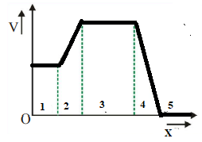
 | a. | 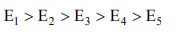 |  |  |  | b.
 | c. |  |  |  |  | d.
In the circuit shown below, if the potential at point A is taken to be zero, the potential at point B is:
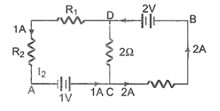
 | a. | +1V |  |  |  | b. |  | -1V
 | c. | +2V |  |  |  | d. |  | -2V
In a metre bridge experiment, resistance box (with R = 2Ω ) is connected in the left gap and the unknown resistance S in the right gap. If balancing length be 40 cm, calculate value of S.
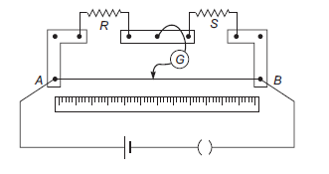
 | a. | 2 Ω |  |  |  | b. |  | 3 Ω
 | c. | 4 Ω |  |  |  | d. |  | 2.5 Ω
In the following circuit figure, the resistance of wire AB is 10 Ω and its length is 1m. Rest of the quantities are shown in the figure. The potential gradient on potentiometer wire will be
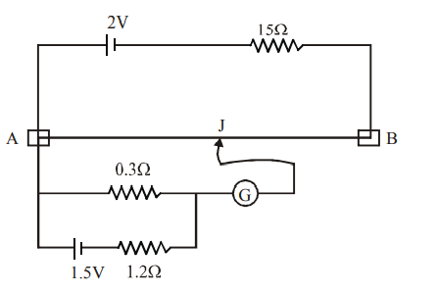
 | a. | 0.8 V/m |  |  |  | b. |  | 0.08 V/m
 | c. | 0.008 V/m |  |  |  | d. |  | none of the above
 | A battery of e.m.f. E and internal resistance r is connected across a resistance R. Resistance R can be adjusted to any value greater than equal to zero. A graph is plotted between the current passing through the resistance and potential difference across it. Select the correct alternative. |  |  |  |  |  | 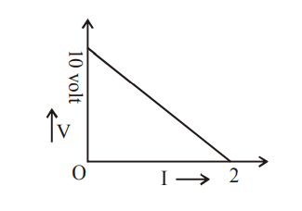
 | a. | internal resistance of the battery is 5 ohm |  |  |  | b. |  | e.m.f. of the battery is 10 volt
 | c. | maximum current which can be taken from battery is 2 ampere |  |  |  | d. |  | all of the above
A rectangular loop of sides 10 cm and 5 cm carrying a current I of 12 A is placed in different orientations as shown in the figures below :
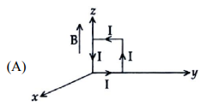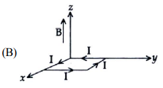
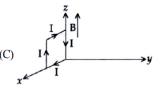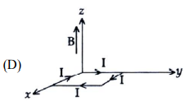
If there is a uniform magnetic field of 0.3 T in the positive z-direction in which orientations the loop would be in (i) stable equilibrium and (ii) unstable equilibrium?
 | a. | (B) and (D), respectively |  |  |  | b. |  | (B) and (C), respectively
 | c. | (A) and (B), respectively |  |  |  | d. |  | (A) and (C), respectively
 | A current carrying circular loop of radius R produces a magnetic field B at its centre.The magnetic moment of the loop is
 | a. | 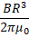 |  |  |  | b. |  | 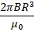
 | c. | 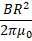 |  |  |  | d. |  | 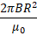
Three long, straight parallel wires, carrying current are arranged as shown in the figure. The force experienced by a 25 cm length of wire C is
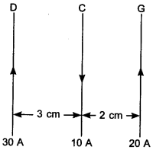

 | a. | 10⁻³ N |  |  |  | b. |  | 2.5 × 10⁻³ N
 | c. | zero |  |  |  | d. |  | 1.5 × ³ N
 | The current i in an induction coil varies with time t according to the graph shown in the figure. Which of the following graphs shows the induced emf (E) in the coil with time 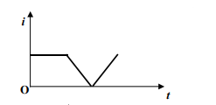
 | a. | 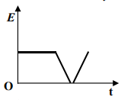 |  |  |  | b. |  | 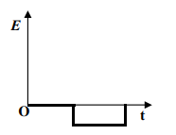
 | c. | 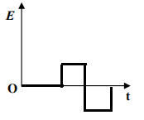 |  |  |  | d. |  | 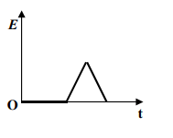
 | A rectangular coil of 300 turns has an average area of average area of 25 cm × 10 cm. The coil rotates with a speed of 50 cycles per second in a uniform magnetic field of strength 4 ×10⁻ ² T about an axis perpendicular of the field. The peak value of the induced e.m.f. is (in volt)
 | a. | 3000π |  |  |  | b. |  | 300π
 | c. | 30π |  |  |  | d. |  | 3π
 | The core of a transformer is laminated so that:
 | a. | the ratio of voltage in the primary and secondary may be increased |  |  |  | b. |  | energy losses due to eddy currents may be minimized
 | c. | weight of the transformer may be reduced |  |  |  | d. |  | rusting may be prevented
 | An electric bulb in series with a large inductor when connected across a DC source takes a little time before reaching a stable glow. If an iron core is inserted into the inductor the time delay of reaching stable glow will:
 | a. | decrease |  |  |  | b. |  | increase
 | c. | remain the same |  |  |  | d. |  | may increase or decrease
For question numbers 45-49 two statements are given- one labeled Assertion (A) and the other labeled Reason (R).
Select the correct answer to these questions from the codes (a), (b), (c) and (d) as given below:
a) Both A and R are true, and R is correct explanation of the assertion.
b) Both A and R are true, but R is not the correct explanation of the assertion.
c) A is true, but R is false.
d) A is false, but R is true.
Assertion (A) : To convert a galvanometer into an ammeter a small resistance is connected in parallel with it.
Reason( R) : The small resistance increases the combined resistance of the combination.
Assertion (A): If electric potential is constant in a certain region of space, the electric field in that region must be zero.
Reason( R): Electric field intensity is equal to negative gradient of potential
Assertion (A): The magnetic poles of earth do not coincide with the geographic poles.
Reason( R): The discrepancy between the orientation of a compass and true north-south direction is known as magnetic declination
Assertion (A): If a proton and an alpha particle enter a uniform magnetic field perpendicularly with the same speed, the time period of revolution of alpha particle is double that of proton.
Reason( R): In a magnetic field, the period of revolution of a charged particle is directly proportional to the mass of the particle and is inversely proportional to charge of particle
Assertion (A): Magnetic field due to an infinite straight conductor varies inversely as the distance from it.
Reason (R): The magnetic field due to a straight conductor is in the form of concentric circles.
III | SECTION C  This section consists of 6 multiple choice questions with an overall choice to attempt any 5. In case more than desirable number of questions are attempted, ONLY first 5 will be considered for evaluation.
 | Two short dipoles each of dipole moment p are placed at origin. The dipole moment of one dipole is along x axis, while that of other is along y axis. The electric field at point (a, 0) is given by
 | a. | 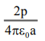 |  |  |  | b. |  | 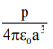
 | c. | 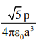 |  |  |  | d. |  | Zero
 | Three charges Q, +q and +q are placed at the vertices of an equilateral triangle of side l as shown in the figure. If the net electric energy of the system is zero, then Q is equal to |  |  |  |  |  | 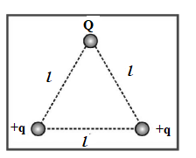
 | a. | - |  |  |  | b. |  | -q
 | c. | +q |  |  |  | d. |  | zero
Case study : Read the following paragraph and answers the questions:

METAL DETECTOR
Metal detectors are useful for finding metal inclusions hidden within objects, or metal objects buried underground. They often consist of a handheld unit with a sensor probe which can be swept over the ground or other objects. Another common type are stationary “walk through” metal detectors. At an airport, a person is made to walk through the doorway of a metal detector, for security reasons. If she/he is carrying anything made of metal, the metal detector emits a sound. When you walk through a metal detector, you are, in fact, walking through a coil of many turns. The coil is connected to a capacitor tuned so that the circuit is in resonance. When you walk through with metal in your pocket, the impedance of the circuit changes – resulting in significant change in current in the circuit. This change in current is detected and the electronic circuitry causes a sound to be emitted as an alarm.
 | At resonance frequency the impedance of A.C series circuit is
 | a. | Maximum |  |  |  | b. |  | Minimum
 | c. | Cannot explain by give data |  |  |  | d. |  | None
An alternating potential V = Vo sin ωt is applied across a circuit. As a result, the current
I = I o sin (ωt ) flows in it.
The power consumed in the circuit per cycle is
 | a. | zero |  |  |  | b. |  | 0.5 Vo Io
 | c. | 0.707 Vo I o |  |  |  | d. |  | 1.414 Vo Io
Which of the voltmeters read zero if the circuit shown is in resonance?
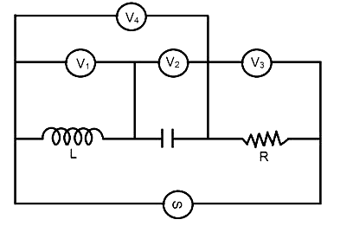
 | a. | V₃ only |  |  |  | b. |  | V₄ only
 | c. | Both V₃ and V₄ |  |  |  | d. |  | Both V₁ and V₂
 | In a non-resonant circuit, what will be the nature of the circuit for frequencies higher than the resonant frequency?
 | a. | Resistive |  |  |  | b. |  | Inductive
 | c. | None of these |  |  |  | d. |  | Capacitive
***

